PS 1-Ques 1

CREATE TABLE 19pw41_employee

(

Name VARCHAR(15) NOT NULL,

Designation VARCHAR(15) NOT NULL,

Dept VARCHAR(15) NOT NULL,

Salary INT NOT NULL,

Phone_number BIGINT(10)

);

PS 1-Ques 2

ALTER TABLE 19pw41_employee

ADD COLUMN ID INT NOT NULL FIRST;

PS 1-Ques 3

ALTER TABLE 19pw41_employee

ADD COLUMN City VARCHAR(15) AFTER Salary,

ADD COLUMN Last_name VARCHAR(5) AFTER Name;

PS 1-Ques 4

ALTER TABLE 19pw41_employee

CHANGE COLUMN Last_name Last_name VARCHAR(20);

PS 1-Ques 5

ALTER TABLE 19pw41_employee

ADD COLUMN Date_of_joining DATE;

PS 1-Ques 6

ALTER TABLE 19pw41_employee

CHANGE COLUMN ID EID INT NOT NULL;

PS 1-Ques 7

ALTER TABLE 19pw41_employee

MODIFY COLUMN City VARCHAR(15) NOT NULL;

PS 1-Ques 8

ALTER TABLE 19pw41_employee

DROP COLUMN Last_name;

PS 1-Ques 9

CREATE TABLE 19pw41_dup_employee AS (SELECT *

FROM 19pw41_employee);

PS 1-Ques 10

ALTER TABLE 19pw41_employee RENAME TO 19pw41_employee_data;

PS 1-Ques 11

DROP TABLE 19pw41_dup_employee;

PS 1-Ques 12

DESC 19pw41_employee_data;

PS 1-Ques 13

INSERT INTO 19pw41_employee_data(EID, Name, Designation, Dept, Salary, City, Phone_number, Date_of_joining)

VALUES (101, 'Smith', 'Manager', 'Accounts', 20000, 'Chennai', 9290249125, '1980-12-27'),

(407, 'Allen', 'Clerk', 'Accounts', 5000, 'Coimbatore', 9945533992, '1981-06-09'),

(678, 'Scott', 'Lecturer', 'ECE', 30000, 'Trichy', 9965542211, '1980-05-01');

PS 1-Ques 14

TRUNCATE TABLE 19pw41_employee_data;

PS 1-Ques 15

ALTER TABLE 19pw41_employee_data

MODIFY COLUMN EID INT NOT NULL UNIQUE;

PS 1-Ques 16

INSERT INTO 19pw41_employee_data(EID, Name, Designation, Dept, Salary, City, Phone_number, Date_of_joining)

VALUES (101, 'Smith', 'Manager', 'Accounts', 20000, 'Chennai', 9290249125, '1980-12-27'),

(407, 'Allen', 'Clerk', 'Accounts', 5000, 'Coimbatore', 9945533992, '1981-06-09'),

(678, 'Scott', 'Lecturer', 'ECE', 30000, 'Trichy', 9965542211, '1980-05-01'),

(747, 'Jones', 'Professor', 'Maths', 35000, 'Coimbatore', 9946673321, '1999-11-12'),

(690, 'Adams', 'Professor', 'EEE', 50000, 'Vellore', 9866544332, '1979-05-25'),

(579, 'Miller', 'Lecturer', 'ECE', 25000, 'Chennai', 9955778890, '1999-12-24'),

(671, 'Ram', 'Asst. professor', 'EEE', 48000, 'Chennai', 9877466335, '1980-10-09'),

(745, 'Allex', 'Senior lecturer', 'ECE', 46000, 'Trichy', 9942266788, '1999-08-19'),

(742, 'Arjun', 'Professor', 'EEE', 48000, 'Coimbatore', 9977886765, '1999-12-06'),

(749, 'Robert', 'Lecturer', 'EEE', 30000, 'Coimbatore', 9866778855, '2005-01-17'),

(845, 'Smyth', 'Clerk', 'Accounts', 9000, 'Salem', 9900007722, '1973-12-31');

PS 1-Ques 17

CREATE TABLE 19pw41_CBE_employees AS (SELECT *

FROM 19pw41_employee_data

WHERE 19pw41_employee_data.City IN ('Coimbatore'));

PS 1-Ques 18

CREATE TABLE 19pw41_Subset_employees AS (SELECT EID, Name, Designation, Phone_number

FROM 19pw41_employee_data);

PS 1-Ques 19

ALTER TABLE 19pw41_employee_data

ADD CONSTRAINT Dept_check CHECK (Dept IN ('Accounts', 'ECE', 'EEE', 'Maths'));

PS 1-Ques 20

ALTER TABLE 19pw41_employee_data

ADD CONSTRAINT Salary_check CHECK (Salary >= 5000 AND Salary <= 50000);

PS 1-Ques 21

ALTER TABLE 19pw41_employee_data

ADD UNIQUE(Phone_number);

19pw41_employee_data

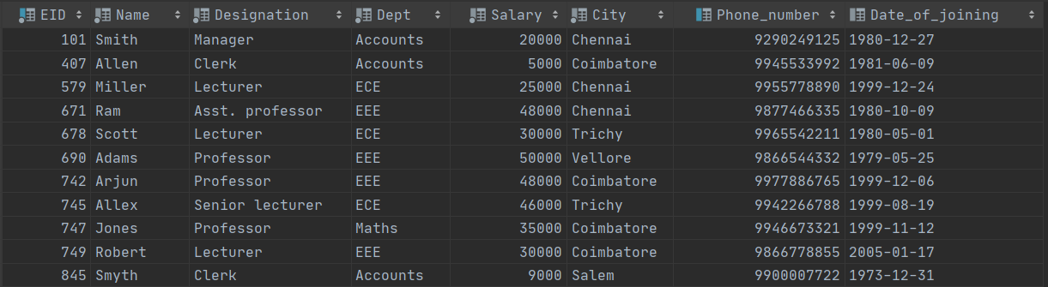

19pw41_CBE_employees

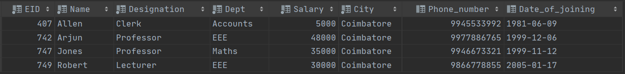

19pw41_Subset_employees

